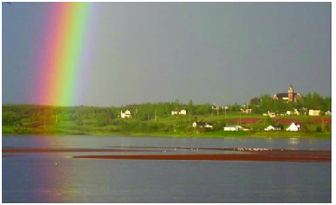
‘CONNECTING PEOPLE WHO CARE WITH CAUSES THAT MATTER”

MANAGED FUNDS

Cemetery Funds
Dundas Cemetery Fund
Highfield Cemetery
Old Protestant Burial
Ground

Masonic Funds
T. Arthur Dawson Masonic
Fund
Island Shrine Club
C. Gordon Lord Scholarship
Fund
MacMillan-Bagnall Shrine
Trust

Other
Architects Assn. of PEI
Hospice Association
ALS Society of PEI
PEI 4H Trust Fund
PEI Hockey
Anonymous #2

Testimonials or???

Managed Funds

ON BEING A TRUSTEE

Canada Revenue Agency, there are over 600 charitable organizations on Prince Edward Island; all are controlled by volunteer boards. Included in that number are an estimated 200 that, in addition to finding and managing operational dollars, have a small nest egg that needs to be taken care of. The latter funds, usually referred to as trusts, are like a savings account or a rainy day fund. The secure the future of their organizations.
Investing for growth is a significant responsibility. For years, simply investing in bonds or other safe investments was all that was required. But times have changed. Now there is an expectation that Trustees will play the role of a prudent investor. Trustees need to be concerned about growing their funds.
And that is where the Community Foundation of Prince Edward Island comes in. We administer endowments, more than 40 at the moment, for Island individuals and organizations. For most, we handle the full administration including receipting the donations, investing, granting, filing reports, etc.

For the organizations listed on the left, however, we have made special arrangements; we include their funds as part of our investment. Ownership remains with the organization, CFPEI simply includes them in our investment pool, report on a investment returns and hand them back if and when requested to do so. It takes the worry out of being a trustee.
The graph below tells you how we have done so far:

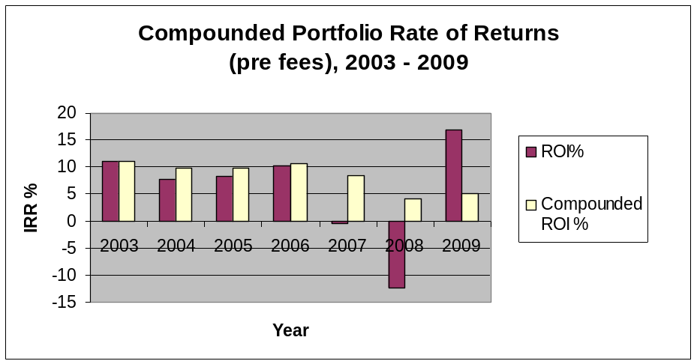
As you will see from the reverse side, we are a registered volunteers agency who rovide a service to individuals and organizations with or wanting to establish endowments.

Talk to a Director or give a a call (902-892-5859). We’d like to talk about providing this service to you.

The Community Foundation
of Prince Edward Island
Ten reasons people choose community foundations.
one
We are a local organization with deep roots in the community, and part of a nationwide movement whose support we build and share.
two
We bring donors to the table as community builders, working closely with them to align their philanthropic vision with the community’s needs.
three
We identify long-term needs and opportunities and invest in solutions that let our communities guide their own future.
four
We take a broad and inclusive view of what a community is, and provide grants to the widest possible range of organizations and initiatives.
five
We provide highly personal and flexible service, accepting a wide variety of assets and offering donors maximum tax advantage.
six
We build permanent funds and those that can respond to immediate needs, helping our communities ensure vital futures.
seven
We multiply the impact of gift dollars by pooling them with other gifts.
eight
We believe that diversity is strength, so we bring the entire community together to stimulate new ideas, build participation and strengthen community philanthropy.
nine
We are transparent and reputable stewards of community resources, committed to being accountable, accessible and responsive.
ten
We build community vitality – the unique and essential spirit that flourishes when people believe their community holds possibilities for everyone.

THE FOUNDATION

The Community Foundation of PEI is a volunteer driven, registered, non-profit, charitable organization. Our mission is to improve quality of life on PEI through the creation and building of endowment funds that will help ensure vital futures for Island communities.

The Community Foundation of PEI provides a means for individuals, families, community groups, corporations, and private foundations to support philanthropic activities which invest in sustainable solutions to community needs. We connect people who care with causes that matter.

The Community Foundation of PEI honours the vision and wisdom of donors and guides disbursements according to their wishes. We facilitate and simplify donor-directed giving and help establish endowments in perpetuity. We manage trust funds with diligence and transparency and adhere to conventional reporting practices.
THE BOARD

Direction is provided by a 12 person, volunteer, community minded Board of Directors representing a broad cross-section of life on Prince Edward Island. Much of the success of the Foundation can be attributed to the hard work and generosity of the individual directors.
CURRENT DIRECTORS

John Robinson Tom Davies Joyce Gaudet
Tracey Laughlin Norman Carruthers Heather MacDonald
Donald Glendenning Lou Ann Thomson David Anderson
Rogers Bell Steve McQuaid Carol Fraser

RECENT ACHIEVEMENTS

- Annual granting of more than $50-60,000 to charitable organizations and causes
- Investment portfolio over $1,000,000
- Developed a network of Summer Islanders interested in giving back to their adopted home;
- Capacity building and leadership workshops for the charitable sector
- Led an $800,000 project to help arts and heritage organizations gain long term stability
- Receipts acceptable to IRS for US citizens

I am impressed with the ability of the Foundation
to design funds that reflect both donor interests and
community needs – Dr. Thomas Hall

The Community Foundation of Prince Edward Island
Suite 105, Queen Square Center
119-121 Queen Street
Charlottetown, PE CIA 4B3
Telephone: (902) 892-3440; Fax: (902) 892-0880
Email: foundation@cfpe.ca Web site: www.cfpei.ca

Registration: Canada: 890011190 RR0001 USA: 30-0050801
02 2010-01-15 Managed Funds A



